Laptop

This Laptop has been designed for seamless productivity and entertainment and this device offers an impressive blend of performance and portability. It is Equipped with a lightning-fast processor and RAM. Its user –friendly design ensures comfortable usage, featuring a backlit keyboard for using even in low-light environments. This laptop is a good option for students, professionals, and anyone seeking reliability and performance in a portable package.

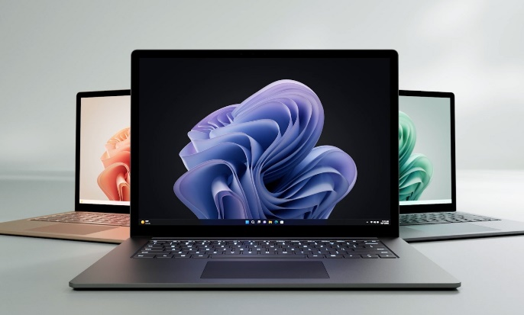

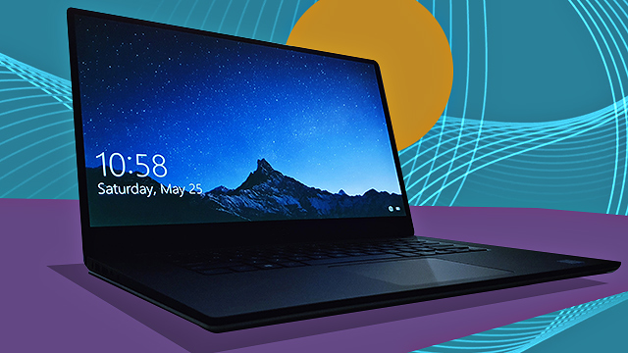

smart phone

Discover the latest in mobile innovation with our cutting-edge smartphone. This device combines stunning design with powerful features, offering a seamless and intuitive user experience.

Powered by the robust processor and RAM, It ensures smooth multitasking performance, whether you're gaming, streaming, or running multiple apps simultaneously.

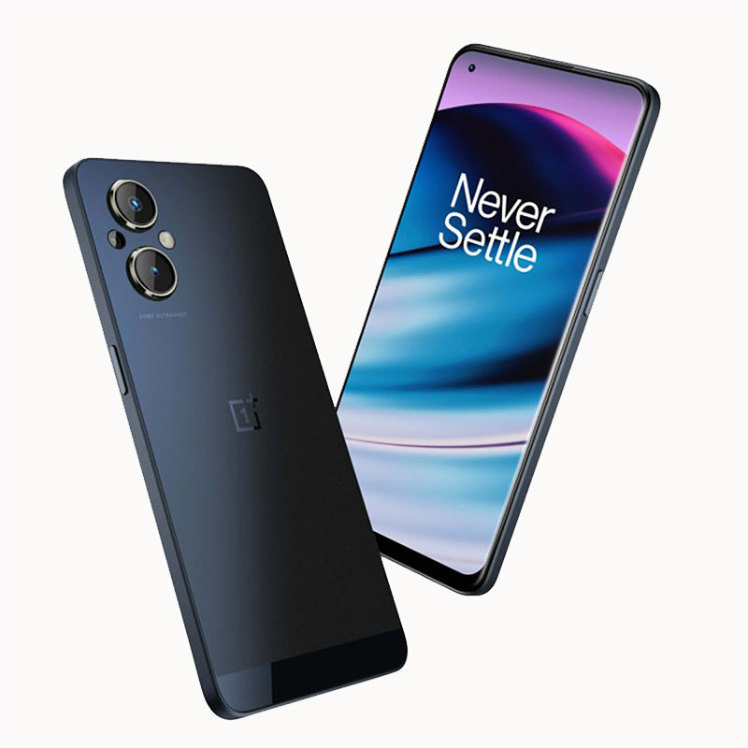 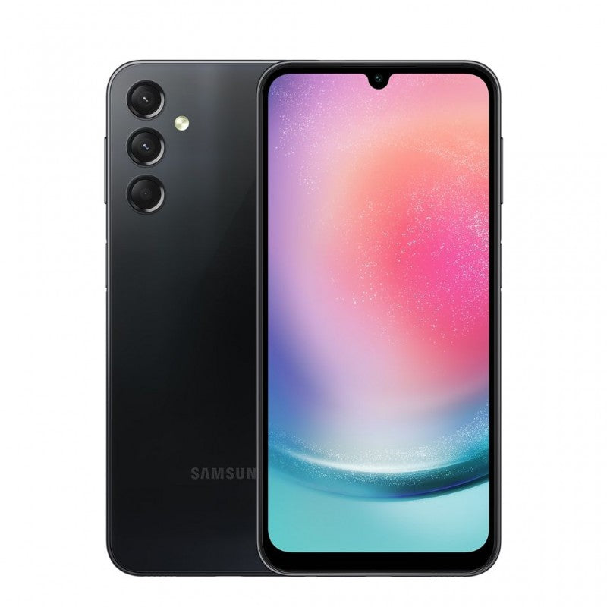

Head Phones

Elevate your listening experience with our premium headphones with exceptional sound quality, for enjoying music, movies, or calls. these headphones offer comfort for extended wear as it is designed with adjustable headband and comfortable ear cups. The advanced noise cancellation technology, long lasting battery life gives the ability to experience a superior audio performance for the user.

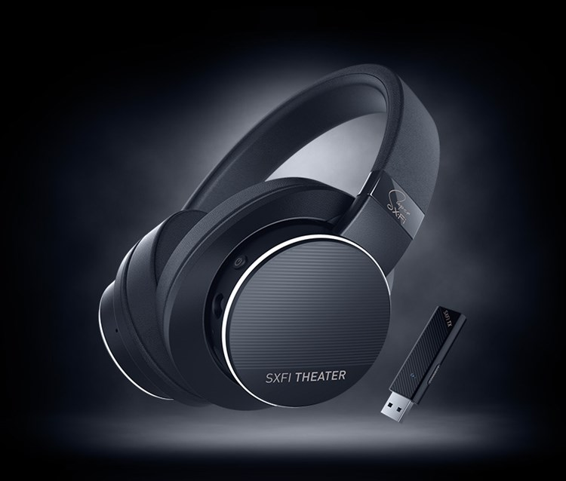

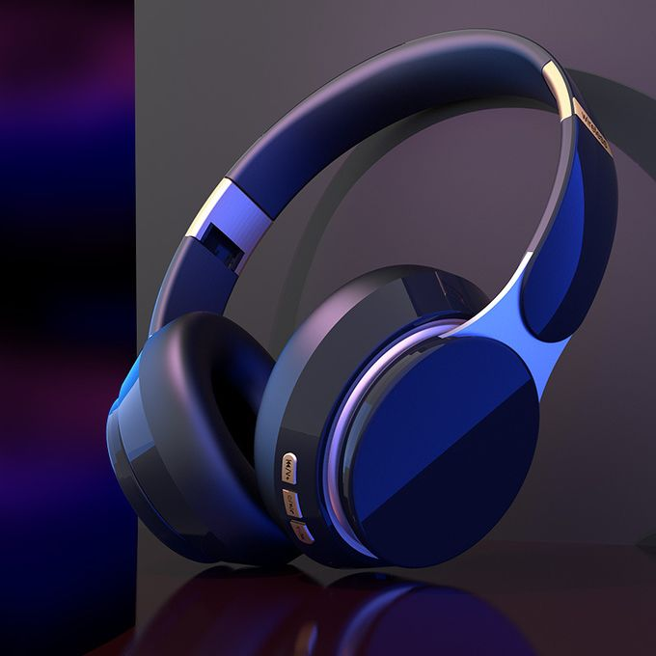

Tablets

Introducing our versatile and powerful tablet which combines portability and functionality which is a perfect option for work, study and Entertaintment. This tablet has a multitasking performance with a good storage facility and a long lasting battery. This tablet has a high resolution camera for capturing of memories.

